Installation:
https://desktop.github.com/download/
Setup:
- Select “clone from the internet”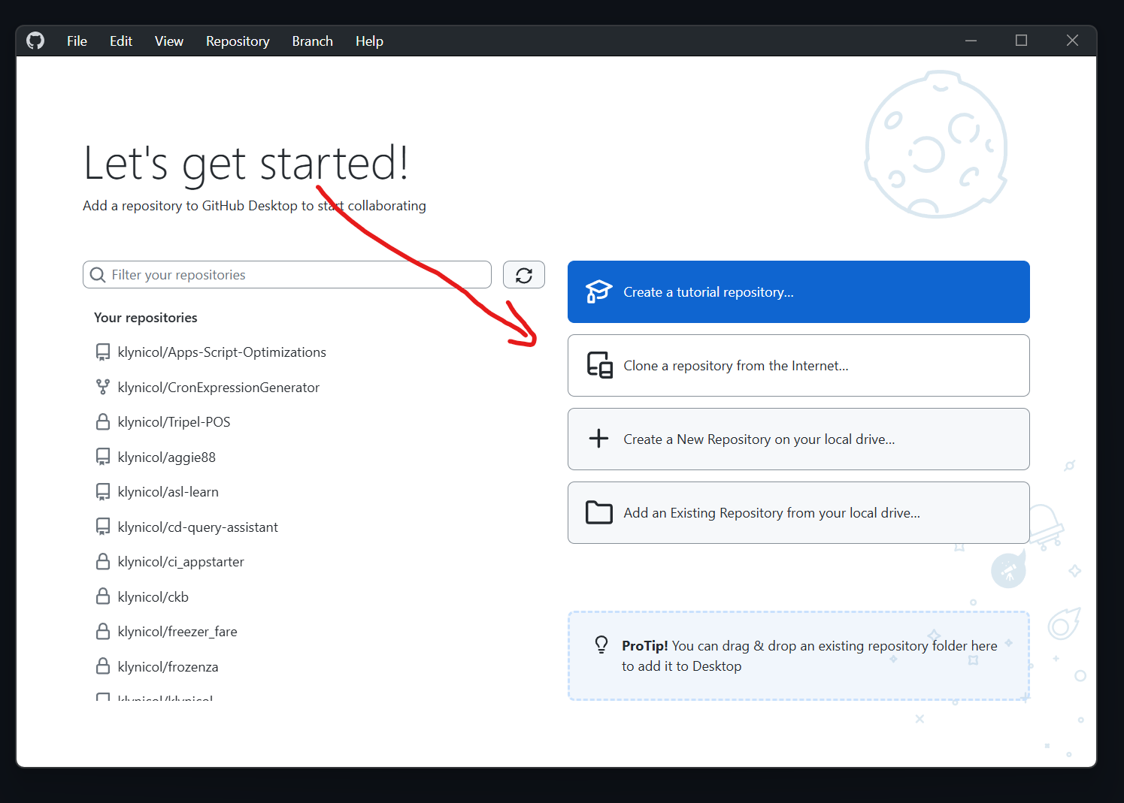
- Paste in https://github.com/klynicol/crimson_year